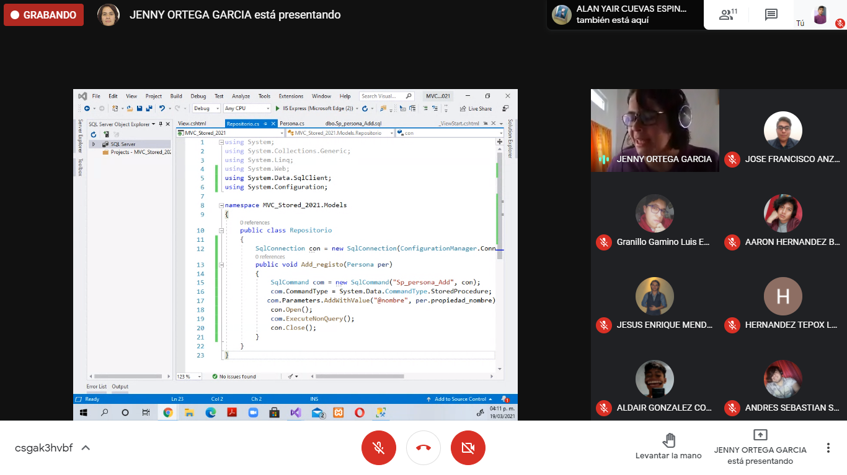

<configuration> <

Con

nectionStrings> <add name="con" connectionString="Data Source=DESKTOP-2H343P1\MSSQLSERVER2017D;Initial Catalog=EntityFrame;Integrated Security=True" providerName="System.Data.Sqlclient" /> </connectionStrings>

